Modeling Social and Non-social Spatial Attention
Alexandra Lee
Bryn Mawr College
August 6, 2010

Abstract

Attention, which is the filter mechanism that allows one to focus on events of interest while ignoring the rest, plays an important role in how we perceive the world and therefore interact in it. In previous research, if a central social cue is followed by a non-social target in the same position, the response time to the target is either facilitated or inhibited relative to the response time to a different position depending on the delay interval and the predictability of the social cue (Hill et al, 2010). We present a model of attention to explain the behavioral data. The model, which is a mechanistic neuronal model using shunting dynamics, includes two parallel and interacting systems (voluntary system and reflexive system). Both the systems were implemented using two identical parallel modules (non-social module and social module). Both modules, which are composed of 8 cells including 4 shape selective neurons (SSNs) and 4 inhibitory interneurons (INs), are organized into two 4-neuron networks at two different spatial locations. Each SSN has an adaptive gain mechanism and is mutually inhibited by a local IN. The model was simulated using Matlab and its ODE45 function. Our modeling shows that as a result of lack of mutual inhibition between neurons responding to the social cue and the non-social target, our simulation showed overall facilitation regardless of the time intervals. This simulation finding was similar to behavioral data (Hill et al., 2010).

Objectives

By studying attention, we can learn about behavioral attention in humans and further understand the dynamics of attention in people with attention disorders such as, ADHD or autism.

In this study, we had several goals: (1) using the published description of a model of reflexive spatial attention (Patel et al. 2009), to develop a similar model of reflexive non-social attention using the Matlab ODE (Ordinary Differential Equations) Solver and to test the model to verify behavioral results seen in the publication of the model. (2) In addition, we sought to create an additional module with similar structure as in [1] for reflexive social attention. (3) Finally, we wanted to combine modules in [1] and [2] into a reflexive system and create a similar voluntary system which interacts with the reflexive system to account for voluntary attention (both voluntary non-social and voluntary social). Thus we sought to create a complete model of social attention, including both the reflexive and voluntary components of attention.

Background

Attention, like memory, is a broad concept and it has been broken down into many kinds of attention. One prominent early theory attempting to explain visual spatial selective attention was called the moving spotlight theory. The primary idea was that spatial attention was like a movable spotlight that could be directed at different targets in the visual field in a serial, sequential fashion. There is a vast amount of information in the environment and attention is helpful with allocating the limited resources available to process the incoming visual information. There are two types of spatial selective attention, reflexive and voluntary. Reflexive attention is an automatic response to salient or pop out stimuli in the environment. In contrast, voluntary attention is a willful response to an event of interest. Furthermore, there is both social and non-social reflexive spatial attention. Social reflexive attention is reflexive attention automatically directed toward a social stimulus, which are stimuli that have social meaning such as human body orientation, face head angle, and angle of eye gaze. Non-social reflexive attention is reflexive attention that is automatically directed toward a non-social stimulus, that suddently appears, changes, or moves (that is, a stimulus that is not important for social interaction such as a shapeor lightning flash,).

Method

Experiment
A participant sits with his/her head in a chin rest facing a monitor and fixating on a central point (Figure 1). The participant performs trials of visual tasks were a series of peripheral stimuli appear. The participant must quickly indicate the location (left or right) of the second stimulus by releasing one of two buttons on a keypad.

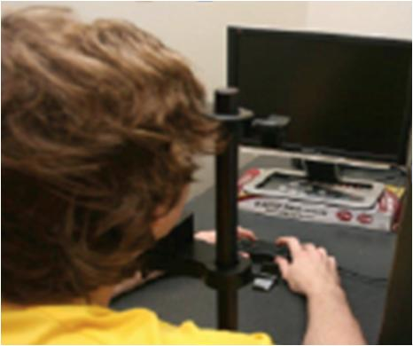
Figure 1: Apparatus to collect behavioral data in non-social and social attention experiments.

Model
The model (Figure 2) is divided into two spatial locations; each location represents an area of the brain that encodes the incoming activity from the eye. The two locations can be thought of as the left and right locations of a person’s visual field. The two locations are symmetric. (1) The reflexive non-social attention model (blue box, Figure 2), which is composed of 8 cells including 4 shape selective neurons (SSN) and 4 inhibitory interneurons (IN), is organized into two 4-neuron networks at two different spatial locations (see expanded white boxes at bottom of Figure 2). Shape selective neurons are those that respond more vigorously, fire more rapidly, to certain stimuli. For example, if a SSN is selective toward plus signs, when a plus sign is presented the neuron will fire more rapidly than it would if a square or another shape were presented. The membrane activity in each neuron, SSN and IN follows the shunting equation. Each SSN has an adaptive gain mechanism and is mutually inhibited (red arrows in bottom white box of Figure 2) by a local IN. The adaptive gain mechanism is a scale factor that modifies the input into each SSN over time. Looking at the white box at the bottom of the diagram, when one SSN is excited then it excites a local IN which then inhibits (red arrow) the other SSN in the network. This inhibition from one SSN to the other and vice versa is what we previously referred to as mutual inhibition. The model was simulated using Matlab and its ODE45 function.
(2) We extended our model of reflexive non-social attention (blue box, Figure 2) to model reflexive social attention (orange box, Figure 2). The extended model, reflexive system (purple box, Figure 2) consisted of two identical parallel modules (reflexive non-social module and reflexive social module) with both modules being implemented using the reflexive non-social model with three exceptions: (a) the reflexive social module had a static weighting function depending on the interpretation of the cue (CI) for each SSN, and, (b) the SSNs in the reflexive social module were responsive to the angle of eye gaze (social stimuli). (c) In addition, the input from the social cue is fed into both spatial locations, unlike the non-social cue being inputted to a specific location. Due to social constructs, we have associations that we make with social cues, such as when we see an eye gazing left we have learned to look left. In fact, some have argued that this ability is present at birth (Farroni, Massaccesi, Pividori, Johnson, 2004). The CI was meant to account for this automatic association that is known to exist. There is a positive CI that benefits the location where the eye gaze is in the same direction as the location. There is a negative benefit to the location where the eye gaze is in the opposite direction as the location. For example, there is a positive CI value on the left location and a negative value on the right location if the eye gazes to the left.. This differs from a peripheral cue that only affects the location where it is presented. This is because the face cue is large and there is one eye to the left and one to the right of fixation; hence, there is information in both locations. The CI modulates the social input in the reflexive system.
(3) We further extended the model to create a complete model of voluntary and reflexive attention (spatial and social). This model included two parallel and interacting systems, voluntary system (yellow box, Figure 2) and reflexive system (purple box, Figure 2). Both the systems were implemented using the extended model described in (2) with two exceptions: (a) in the voluntary system, the weighting function in the social module was dynamic and depended on the interpretation of the cue (CI), and (b) a separate external input related to the predictability of the cue (CP) modulated the baseline activity of all SSNs in the voluntary system. The CP is a scale factor that adjusts the baseline activity in the voluntary system by increasing the baseline activity if the gaze cue predicted the location of the target and decreasing the baseline activity if the gaze cue was non-predictive of location. Additionally, the summed activity of all the SSNs in the voluntary system tonically inhibited (TI, red arrow, Figure 2) all the SSNs in the reflexive system. The complete model models the decision making process in deciding the location, left or right, that the target appears. The final output of the model is the maximum membrane activity between the two spatial locations. The simulation results from the model are plots of the spatial cueing effect as a function of CTOAs. The spatial cueing effect is the response time from the uncued trial minus the response time from the cued trial. To obtain the spatial cueing effect we first integrate the output curve from each trial type over a 50 millisecond window after the onset of the target. The resulting value from this integration is the modulation for the baseline manual response time from the participant performing the experiment. The modulation from the cued trials is subtracted from the modulation from the uncued trials to yield the value to get the spatial cueing effect. The larger the cueing effect the faster the response time. If the left location has greater membrane activity then the participant will respond “left” as the location of the target. 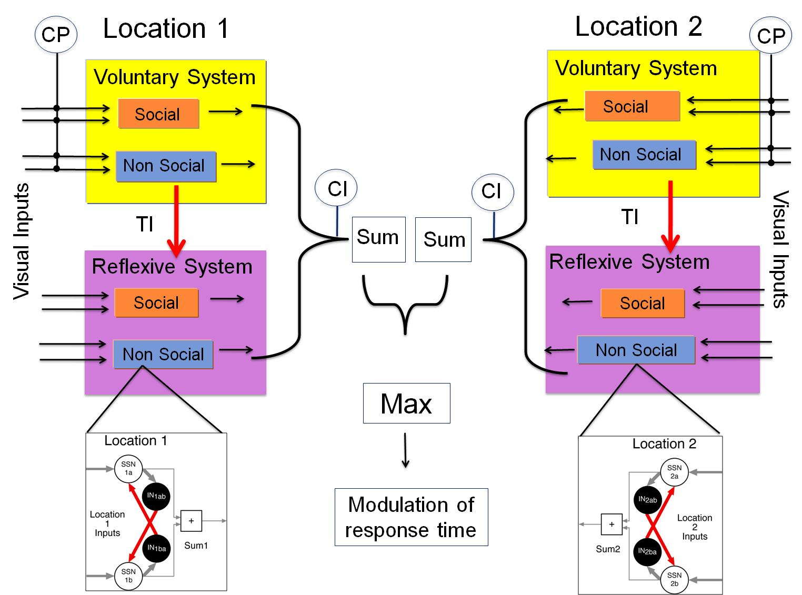Figure 2: Model of non-social and social attention.
Results

Non-social Attention Model

In a typical reflexive spatial attention paradigm (Figure 3), response times are collected to measure how quickly a participant can indicate the location of a target presented on a monitor (see also, Posner & Cohen, 1984). The participant fixates on a central fixation point for a period of time. Then a non-social cue appears randomly in either the left or right periphery, which is either to the left or right of the central fixation point. After the cue appears there is a delay period, called the Cue to Target Onset Asynchrony (CTOA or “delay”), where the participant returns to fixating on the central point. Then a non-social target is presented randomly in either the left or right periphery. The participant responds to the location of the target using a keypad with two buttons that correspond to one of two spatial locations, which correspond to the location of the target (i.e. if the target appeared on the left periphery then the participant would release the left button). There are two types of trials, cued and uncued. Cued trials (top row, Figure 3) are when the cue and target are presented in the same spatial location. Uncued trials (bottom row, Figure 3) are when the cue and target are presented in different spatial locations. 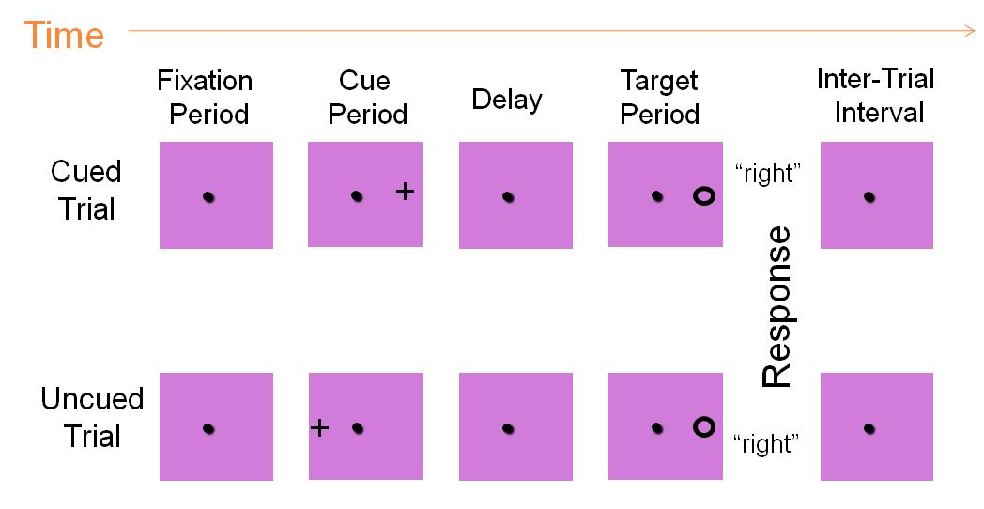
Figure 3. Patel et al. Paradigm (2010)
The behavioral results from the paradigm showedthat there was facilitation and inhibition of the response to the target depending on the spatial locations and the CTOAs. At short CTOAs the response times to the target were facilitated (faster) for cued trials; there was a positive cueing effect. At longer CTOAs the response times were inhibited (slower) on cued trials; there was a negative cueing effect.
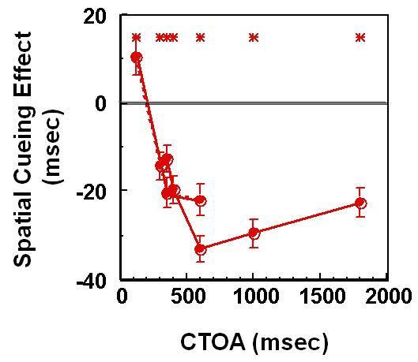
Figure 4. Data from the above Posner’s paradigm (Patel et al, 2010). Solid and dotted lines for cue duration of 200 and 83 msec respectively.
We modified a model of reflexive non-social attention using the paradigm described above. The model was described above in Figure 2 in the white box. Simulation results of model in Matlab using ODE45 function are seen below. Different shape selective SSNs in the non-social module of the reflexive system were stimulated. These results qualitatively mimic the behavioral data shown above. There is facilitation at short CTOAs and inhibition at longer CTOAs.

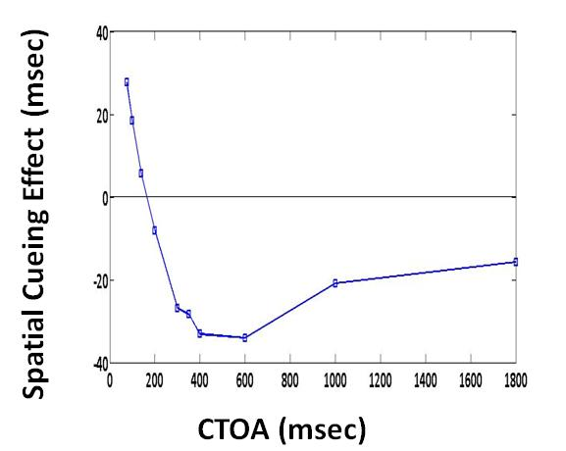
Figure 5. Simulation results of the Reflexive non-social model using MATLAB.
Social Attention Model
Extending the reflexive non-social attention paradigm, a social attention paradigm replaces the shape (nonsocial) cue with a face (social) cue with eyes gazing to either the left or the right. The set up of this social attention paradigm is the same as the spatial attention paradigm (Fixation, cue, delay period, target then response) except that the cue is large and presented in the central region of vision (thus, stimulating both left and right locations). The paradigm has two trial types -congruent and incongruent. On congruent trials the non-social target is presented in the same direction as the eye gaze of the preceding social cue. In Figure 6 on the top row, the eye gazes to the right and the target appears on the right. On incongruent trials, the non-social target is presented in the opposite direction as the eye gaze of the preceding social cue. Figure 6, bottom row, illustrates and example of an incongruent trial with the eye gaze to the left and the target appears on the right. There are two conditions using this paradigm: Voluntary (Predictive) and Reflexive (Non-predictive). For the Voluntary condition the social cue has predictive value and so the cue predicts the location of the target. There are two subtasks within this condition: Pro-gaze (PG) and Anti-gaze (AG). The PG subtask is when the participant is informed that the target will be in the same direction as the gaze cue appears 100% of the time. The AG subtask is when the target is in the opposite direction as the gaze cue appears 100% of the time. In the experiment using the voluntary condition, the participant has blocks of PG and AG subtasks. The results for this voluntary condition account for the voluntary component of attention in the model, at which time the CP input was added. For the reflexive (non-predictive) condition the direction of the gaze cue has no predictive value as to where the target appears. In the experiment using the reflexive condition the there is a random mix of congruent and incongruent trials. The results of the reflexive condition account for the reflexive attention in the model.
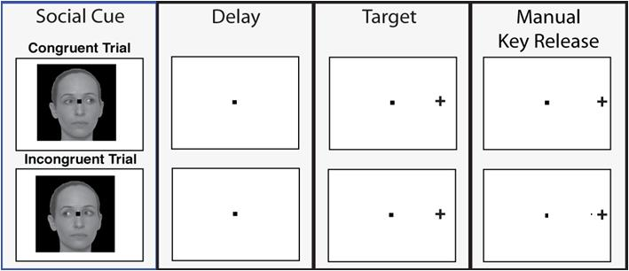
Figure 6. Social Attention Paradigm using eye gaze cues.
Looking at the results of the paradigm for the reflexive condition, the response to the target was facilitated by the face cue at all CTOAs (Figure 7). The response times for the face cue with eyes gazing towards the target location (congruent trial) was always faster than the face cue with eyes gazing away from the target location (incongruent trial); there is a positive cueing effect for all CTOAs, despite the fact that the target was equally likely to appear in the location of the gaze or the location opposite the gaze.
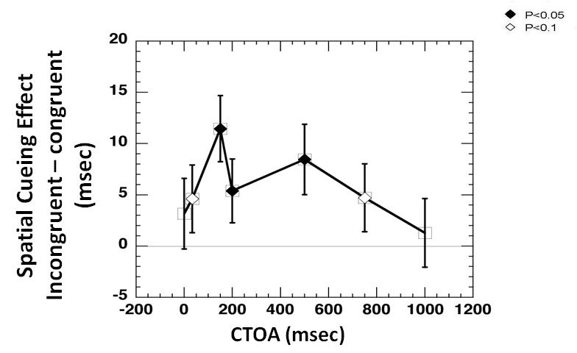
Figure 7. Behavioral data of reflexive social attention from the above social attention paradigm.

created a model of reflexive social attention, which was previously describedin Figure 2 in the orange box. . We simulated the model of reflexive social attention in Matlab using ODE45 function as seen in Figure 9. We . These results qualitatively mimic the behavioral data shown above. There is facilitation at all CTOAs

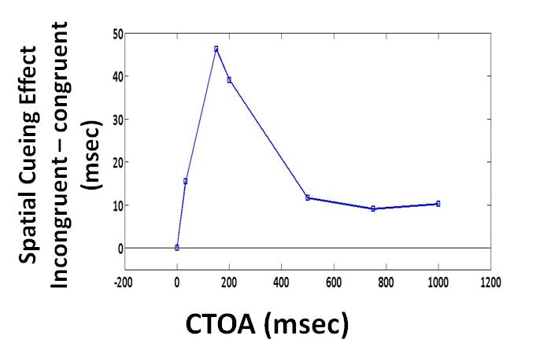
Figure 8. Simulation results for reflexive social attention using Matlab

Comparing the tests for the predictive and non-predictive conditions, we get the behavioral results for the voluntary attention system. In the voluntary condition, there is inhibition of the response to the target at short CTOAs and there was facilitation at longer CTOAs (Figure 9). At short CTOAs the response times of the congruent trials were slower than the response times of the incongruent trials. At longer CTOAs the response times for the congruent trials were faster than the incongruent trials. We are currently working to model and simulate this data using Matlab.

Figure 9. Behvaioral data of voluntary social attention using the same paradigm above.

Discussion and Future Works

We successfully implemented a model of non-social reflexive spatial attention whose outputs qualitatively mimicked the facilitory and inhibitory effects seen in the behavioral data. For the first time, we extended the model of reflexive spatial attention to social stimuli (eye gaze), and showed that the model simulation results are qualitatively similar to the behavioral findings in reflexive social attention. We have shown that there is overall facilitation for Reflexive social attention. We believe this difference in attentional timecourse between non-social and social paradigms is a result of lack of mutual inhibition between neurons responding to the social cue and the non-social target. Further testing of this conjecture is needed to determine if this is the case. Testing of voluntary social attention is currently in progress.

References
- Patel SS, Peng X, Sereno AB. Shape Effects on Reflexive Spatial Selective Attention and a Plausible Neuorphysiological Model. Vision Research 2010.
- Hill JL, Patel SS, Gu X, Seyedali N, Bachevalier, Sereno AB. Social Orienting: Reflexive versus Voluntary Control. Vision Research 2010.

Grice SJ, Halit H, Farroni T, Baron-Cohen S, Bolton P, Johnson MH. Neural correlates of eye-gaze detection in young children with autism. 2005

Acknowledgements

This summer research project was supported by a NSF REU Grant DMS-???.
Anne B Sereno, Saumil S. Patel, Stuart D. Red

