Fundamentals of Cellular Imaging

Tutorial
for
REU Program 2008

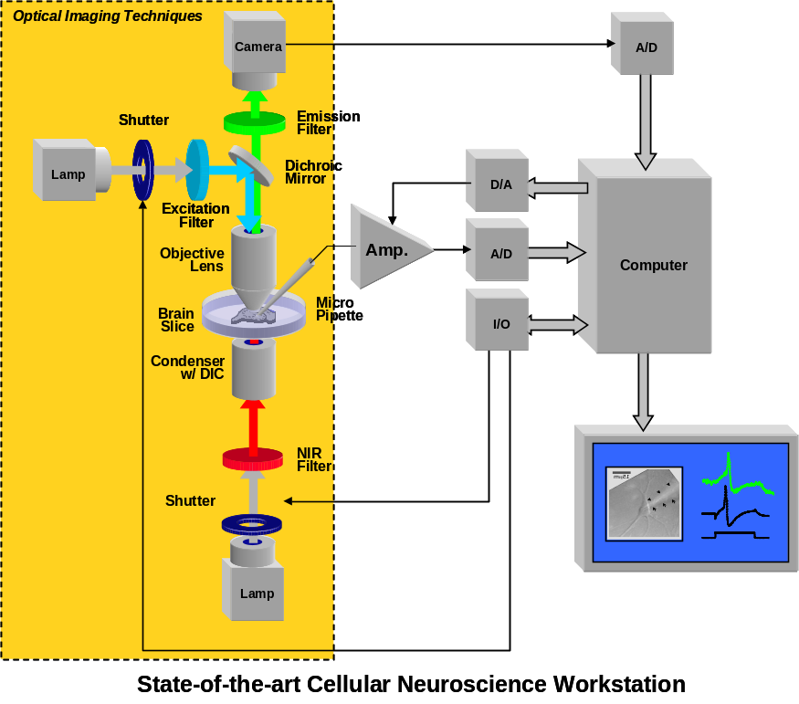

In my tutorial, I will cover the following topics:

1. Fundamentals of Light Microscopy: Lenses, Human Eye, Basic Optical Devices
2. Quantitative Light Microscopy: Resolution, Brightness, Fluorescence
3. Fluorescent Labels and Indicators: Ion-sensitive, Voltage-sensitive Dyes
4. Imaging Instrumentation: Light Sources, Filters, Detectors
5. Scanning Microscopy: Confocal M, Multi-photon M
6. Examples of Cellular Imaging: Membrane Potential, Intracellular Calcium

After the tutorial, you should be able to explain to another student who was not able to attend the tutorial how a light microscope should be configured and used to image the activity of a living cell, e.g., the transient change of the calcium concentration in the dendrite of a pyramidal neuron during a back-propagating action potential.

